SOFTWARE ENGINEERRING - CSA1086

GIT BRANCHING AND MERGE

1. Navigate to Your Local Repository

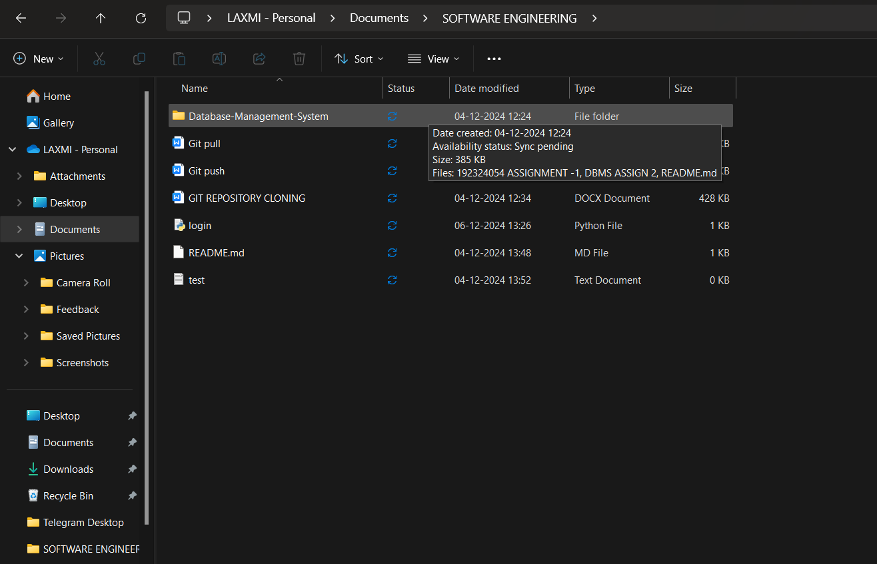

1. Create a New Branch

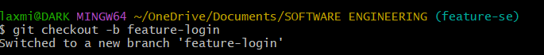

1. Add a login.py File with the Login Function



1. Add, Commit, and Push the Changes

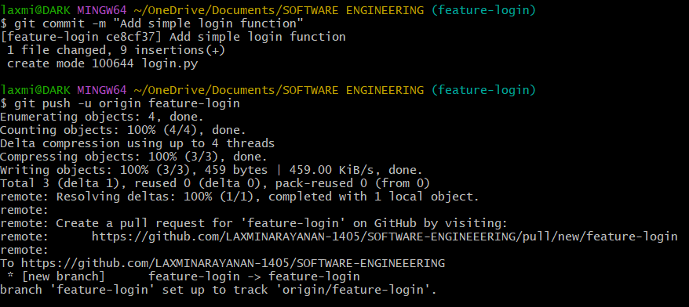

1. Create a Pull Request on GitHub

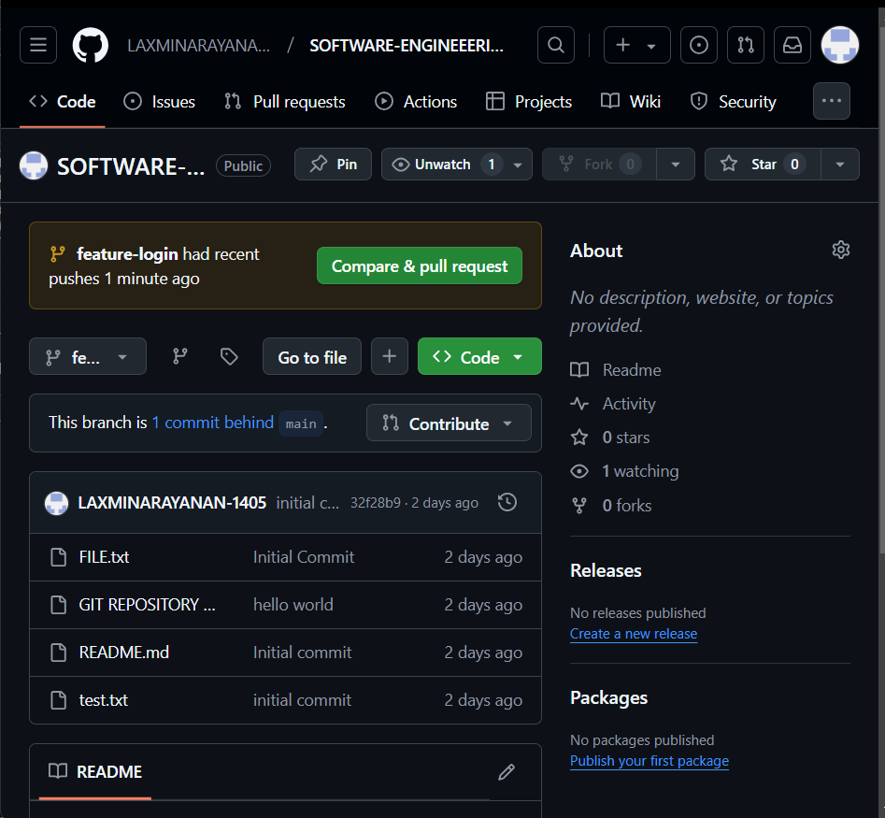

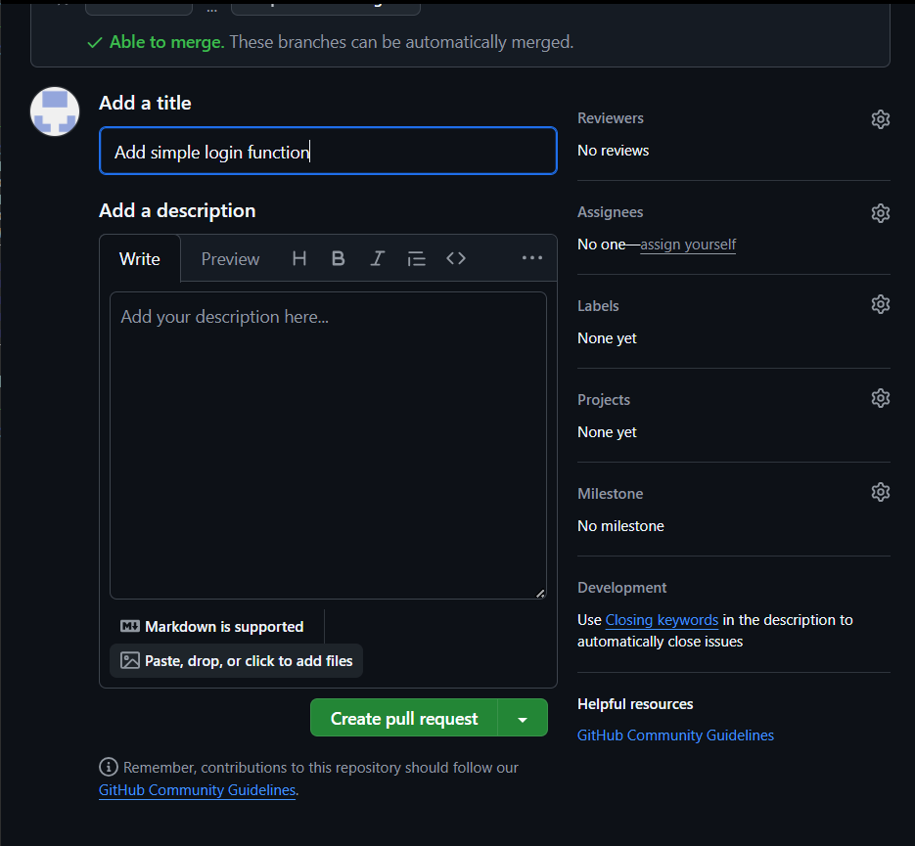

1. Merge the Pull Request

